**Lesson 4 Demo 2**

**Create and Clone a GitHub Repository**



Steps to be followed:

1. Create a new Github repository
2. Edit the README file
3. Upload a file to the repository
4. Clone the Github repository

**Step 1: Create a new GitHub repository**

1.1 Open a browser in your lab, go to **github.com,** and log in to your account.

1.2 Click on the **+** icon from the upper-right corner of the page, and select **New repository** from the drop-down menu.

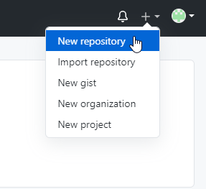

1.3 Enter *sample repository* in the **Repository field.** Entering a **Description** is optional.

1.4 Choose **Public** for the repository type.

1.5 Select **Initialize this repository with a README** to include a *README* file for the repository.

1.6 Click on the **Create Repository** button.

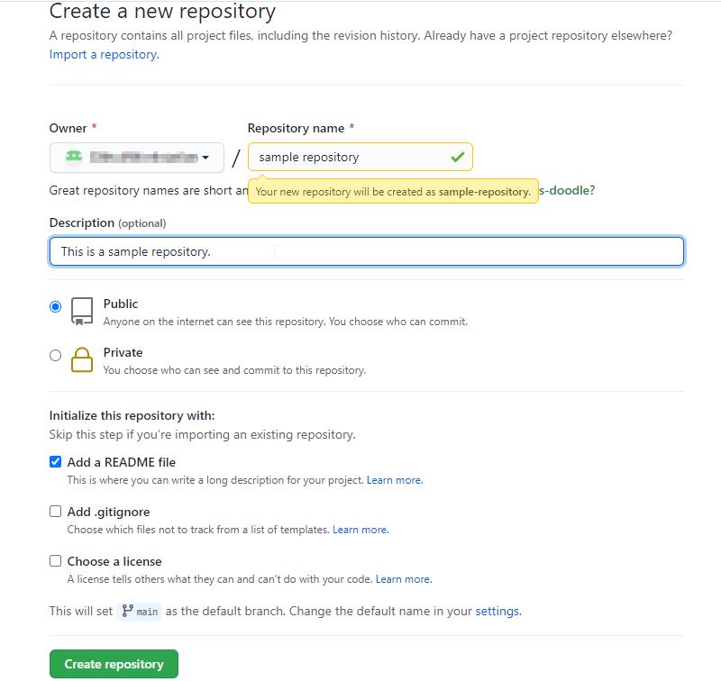

**Step 2: Edit the *README* file**

2.1 Click on the **Edit** button to edit the *README* file.

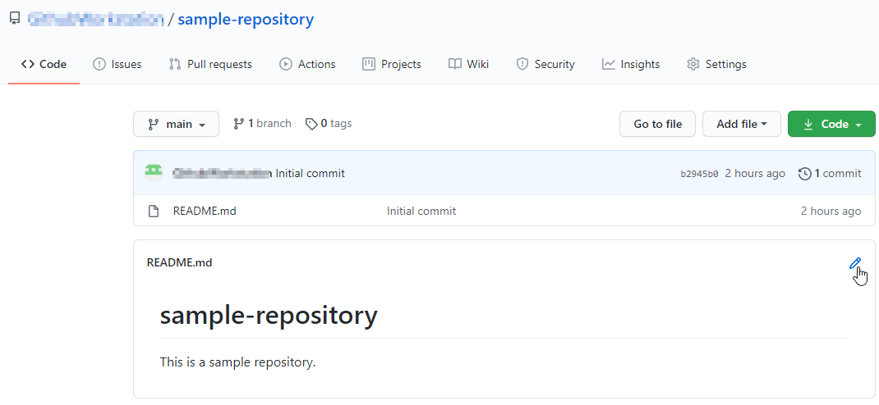

2.2 Add some text in the README file (Example: *We have edited the README file.*)

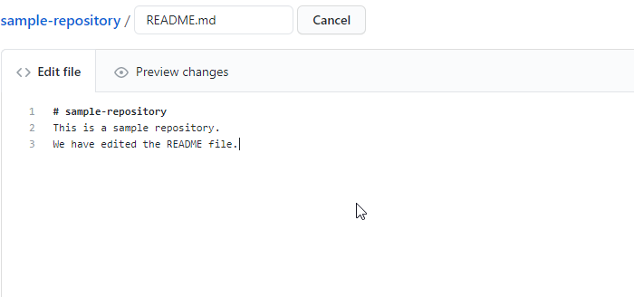

2.3 Type a commit message to describe the changes made in the file and then click on **Commit changes**

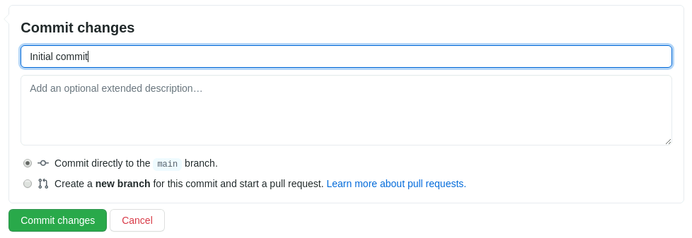

**Step 3: Upload a file to the repository**

3.1 Go to your Github repository and to add a file to the repository, click on **Add file**, and then select **Create new file**

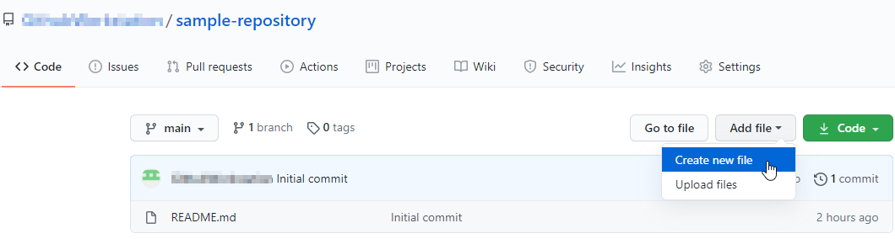

3.2 Enter the filename as **SampleFile.txt,** and add the following text in the **Edit new file** tab.

*This is a sample file.*

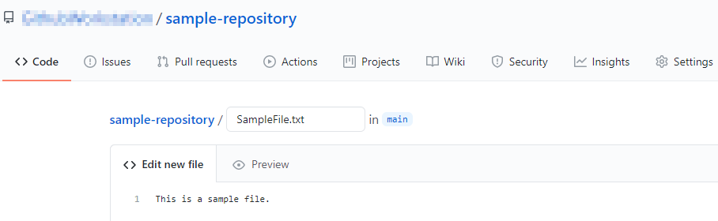

3.3 Next, scroll down to the **Commit New File** section. Write a Commit Message (**Example:** *Create SampleFile.txt*) and click on the **Commit New File** button

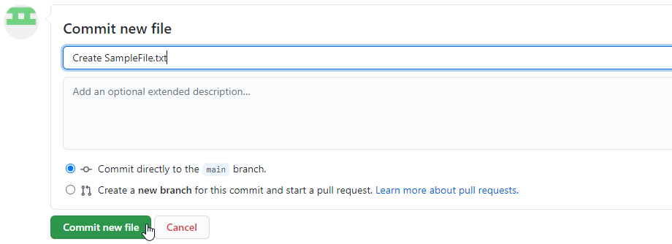

3.4 Check the newly added file with the commit message

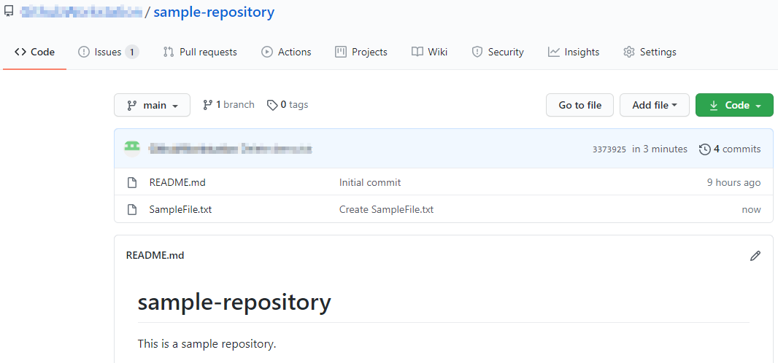

**Step 4: Clone a GitHub repository**

4.1 Open the browser in your lab, go to **github.com,** and login to your account

4.2 Open the **sample-repository** repo, and click on the **Code** button.

4.3 Click on the icon as shown in the following image to copy the **url** provided under **HTTPS.**

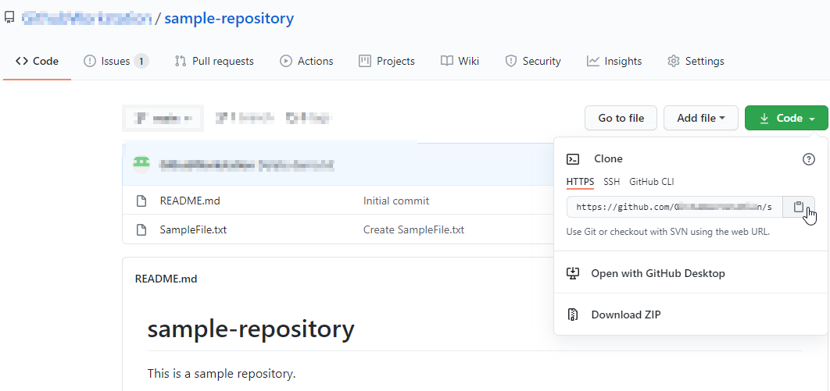

4.4 Open the **Terminal** tab on your lab, and use the following command to clone the repository:

**git clone URL**

**Note:** Replace the URL with the copied URL from the repository.

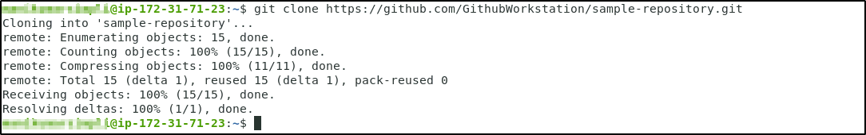

4.5 Use the following command to check the cloned repository:

**ls**



4.6 Navigate to the **sample-repository,** and check the files inside the repository.

**cd sample-repository**

**ls**

